9/18/2022 7:47:23 AM

* Youth protection training in a group?
* Pass off for people otp
* Budget - Negative administration
* Rights for Acess to reports & rolls?

Ward Clerk todo list

Last update:

8/21/2022 8:38:45 PM

* Submit Bishops receipts.
* Document expense submission process
* Itemized receipt
* Don’t use lds tools app yet (as of about 8/21/2022 8:39:01 PM)
* Clearly enter the tax as seen on the receipt (this is big deal for church as we’re tax exempt.
* Please add your bank info, or EFT if you’d like direct deposit. This saves time for everyone involved. If you prefer not to, please let us know.

Need to docume 288 expense, talk about at bishopric.

TODO:

* Get Mike and Kerry a keyfob and metal key for the church.
* Make sure Mike and Kerry know how to print checks.
* Write up history of Eva Welch for support payment, just to record context.
* Clean up email

QUESTIONS:

Bishop:

* (is this still valid?) did we want to get your inlaws set up to stream the sacrament?
* Kim get records moved
  + 5/1/2022 5:31:00 PM- from Kim Ball: Waiting on Ryan Elder’s new address &ward
* Bro Burrows:
  + 5/1/2022 5:31:50 PM - Send callings spreadsheet to update records

- Report slow internet issues

- Slow computer issues.

- Discuss password update maybe? Is this decided at the church level?

Finance:

* Setup regular reporting of budgets.

- Key Audit:Document Keys and who has them:

- For keyfobs without serial numbers, give new ones.

- Document who has which serial numbers.

- Find a way to cover serial numbers.

- Get pictures of ward members into LDS.org.

HISTORICAL:

5/1/2022 4:01:29 PM - Megan Gossett & pinewood derby

- Parents will be donating by giving bishopric cash.

5/1/2022 4:02:17 PM - done today: short expense training,a nd printed one check.

5/1/2022 5:05:59 PM- Switched biling to Bishop’s card, and John is ‘upgrading’ google cloud account to resolve dns issues.

5/1/2022 5:06:20 PM - Sent Releases spreadsheet send to burrows

* 5/1/2022 5:20:43 PMPost LDStools app clean up to website

Instructions for adding your reimbursement account:

Steps:

1. Click on your image icon (it will just be your initials if you don’t have an image on lds.org) as shown here.
2. Click on ‘Donations’:

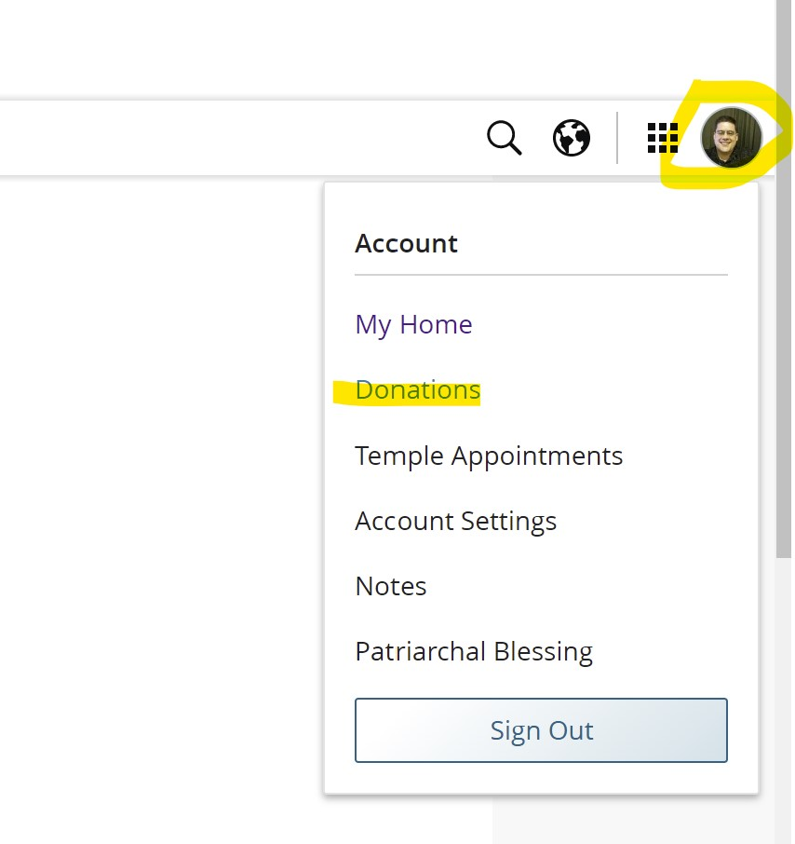

1. Donations -> Settings:

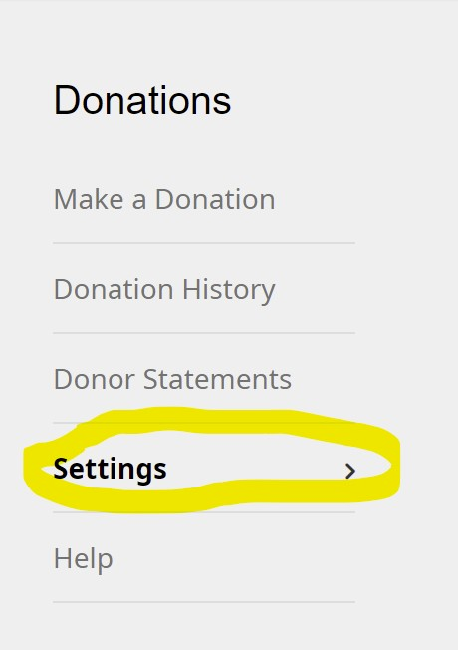

1. Add an ‘Expense Reimbursement account. Note that your Donation account is how you can pay tithing on line, you must add the ‘Expense reimbursement account’ though it can be the same account:

